


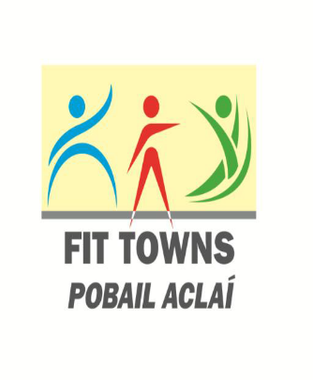
FIT TOWNS EVALUATION FORM 2017
(One form to be completed for each activity in the programme)

Section 1
Name of Programme.
Description of the Activity.
Tutor/Facilitator
Where it took place
Date(s) it took place | Start ___ /___ /___ End ___ /___ /____

Is the activity on-going? YES. NO.

If Yes, describe below how the activity continues and how many are participating.

Section 3
How many participants took part in the activity/project?

Please give details of the type and number of participants involved in the activity/project from each of groups listed below:

Place a tick (✓) appropriate boxes.

- Youth Numbers
- Disadvantaged Numbers
Backgrounds
- People with Numbers
Disabilities
- Women/Girls Numbers
- Older Adults Numbers
- Ethnic Minorities Numbers
- Unemployed Numbers

8 Number of coaches/volunteers involved in the project?

Section 4.
Please outline the costs of this activity/project if any, tutor/facilitator costs, benefit in kind, facilities, equipment etc.
Item | Amount
Total: | €

Section 5
Please provide a list of outcomes from the activity/project: (Use separate page if necessary)

Section 6.
If activity/project is to be sustained into the future please give details of how this will be done to the benefit of those who continue to participate and those who may join.

1
2
3

What worked well in the project? (Use separate page if necessary)

1
2
3

What were the main obstacles/difficulties in running the event/project. (Use separate page if necessary.

1
2
3

Section 7.
Any other information you feel is relevant to the project:

** Please attach any photographs or other material, relevant to the programme you may have of this particular event.

Signed; _________________________________________ Date; ___________________
(Chairperson of Club or Person in Charge of Project).

Completed reports must be returned to Galway Sports Partnership by Monday 12th June 2017.

Return address:

Galway Sports Partnership,
c/o Galway Co. Co.
Co. Hall
Prospect Hill,
Galway

or by scan and e-mail to galwayactive@galwaycoco.ie.

